# Ryan Timbrook

## IST 659 Data Admin Concepts &Db Mgmt

## Date: 7/30/18

## Lab Assignment: Lab 3, Logical Modeling

## Description / Learning Objective

* Demonstrate understanding of the logical model
* Demonstrate ability to convert conceptual ERDs to logical model diagrams (E-ERDs)
* Identify the appropriate cardinality and degree of relationships
* Identify data types using narrative elements and prior domain knowledge

## Responses:

### Part 1, Logical Modeling - Case Study 1 – Obligatory College Classes Modeling

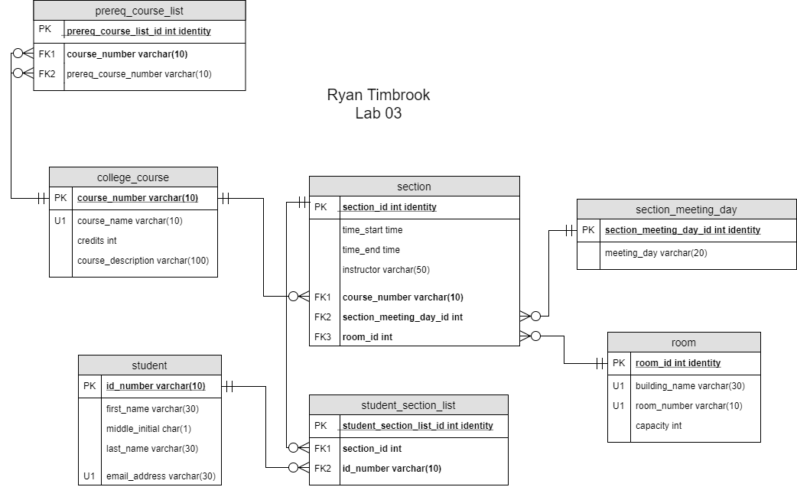

### Part 1, Logical Modeling - Case Study 2 – Project Management

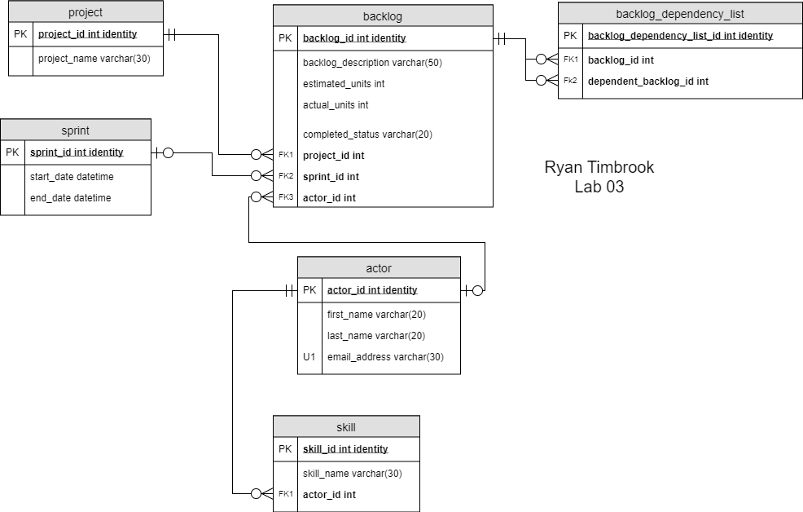

### Part 1, Logical Modeling - Case Study 3 – Book Publishing Database

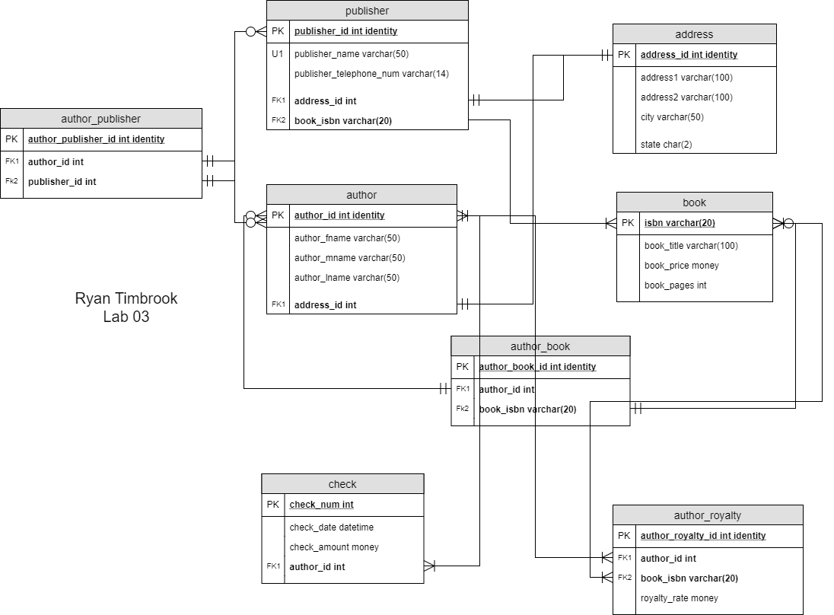

### Part 2, Part 1 – VidCast Logical Model

